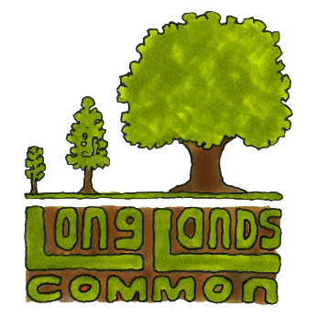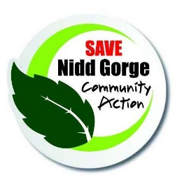

Be A Campaign Champion For Long Lands Common - Age 11+ Category

Please Note * Each person that completes this challenge successfully will receive a Long Lands Campaign Champion certificate. These can be used as evidence for your Duke of Edinburgh Award - Voluntary task, see: https://www.dofe.org/wp-content/uploads/2019/03/programme_ideas_-_complete.pdf
and also as evidence for Scouts and Guides badges.

Brief:

Design a Long Lands Common publicity campaign which encourages people to pledge to buy a share.

Objectives:

- Due to Coronavirus Covid 19 it is hard to communicate face-to-face at the moment with people that don’t live in the same household as us. Your campaign will use a range of communication skills to help overcome this, and allow people to engage with the Long Lands Common project at a safe distance. Methods you might choose include: email and social media (please ask your parents’ permission to do this and if you do not have a social media or email account, perhaps they will let you use theirs?); a YouTube video or stop animation; homemade banner or poster displayed at home on a gate facing into your street and phone calls to self-isolating friends and family. Don’t just copy these examples, please also include some of your own unique approaches as well to put your individual stamp on your campaign.
- As well as passing on the project’s key messages (including importantly how to purchase community shares) your campaign should be creative, fun and memorable.
- Your campaign should encourage others to pass on the news about Long Lands Common, get involved and ultimately get people to pledge to buy a share on our ‘pledge’ page: https://www.longlandscommon.org/pledgetobuyashare
- If some of your contacts want to pledge and cannot access the internet, you could offer to register their details for them.

Resources:
- Long Lands Common promotional posters (link needed)
- The official Long Lands launch video: (link needed)
- You should find all the background you need about the community owned woodlands project, Long Lands Common, by exploring www.longlandscommon.org
- If you do have specific questions that you cannot find answers to on the website, please send us a message at info@longlandscommon.org

How to enter:

- Register your intention to start your promotional campaign here: https://www.longlandscommon.org/volunteer giving us a summary of your intentions and ideas.
- Put your campaign ideas into action and write a summary of what you did, what happened and any feedback you received.
- Encourage your audience to mention your promotional campaign when pledging to buy a share
- Tell us about your full campaign in a word document, powerpoint presentation or video etc, and send an email, along with any evidence of campaign elements like poster and banner artwork and videos to - info@longlandscommon.org
- Please note that if you are using photographs or videos you must gain the consent of any people appearing in them. If there are any under 16s involved, including yourselves, you must have gained consent from a parent or guardian first.

Deadline:

The deadline to submit your campaign evidence is 30th June 2020.

Please note that by sharing your ideas with us, you agree to them being used for our own promotional activities, including social media. Your campaign work will be attributed to you. We look forward to hearing from you.

